My Personal Commerce Account-Banking Application User Guide

Team 7

Team Members
Scott Howard
Maryam Albakhiet
Grant Jenkins
Mariam Habib
Irem Atik

Contents
Contents 2
1 Introduction 3
2 Quick Start Guide 3
3 System Requirements 4
4 Main Scenarios of Use 4
4.1 Create an Account…………………………………………………………………………………………………….4
4.2 Update User Profile………………………………………………………………………………………………….6
4.3 Add an Account………………………………………………………………………………………………………12
4.4 Add a Transaction…………………………………………………………………………………………………..13
5 Troubleshooting
14
5.1 Forgot Password…………………………………………………………………………………………………....14

Introduction
The My Personal Commerce Account Banking application is a web application available to anyone who has access to the internet. It will provide Commerce Bank customers with an online system that pulls in transaction details and allows users to set triggers for notification rules and receive notifications around them.

Quick Start Guide
- Login to your My Personal Commerce Account Banking application by typing https://commerce.umkc.scottah.com/ into your web browser. The Sign In screen will be brought up.
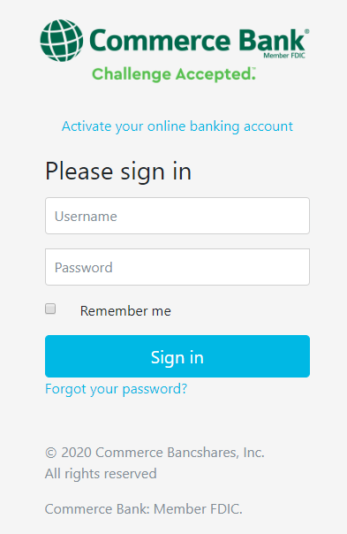
- Enter your Username and Password that is associated with your account.
Click Remember me if you would like your computer to store your login information, allowing you to skip the login process when returning to the web application.
- Click the Sign In button.
- This will redirect you to your Dashboard.

System Requirements
My Personal Commerce Account Banking Application is designed to work on modern browsers for customers with Commerce Bank accounts. This application will interface with SQL Server as the relational database management system and will be used on Windows, Mac OS, and Linux systems. Please refer to the System Documentation Guide for further instructions on installation.

Main Scenarios of Use

Create an Account
- Type https://commerce.umkc.scottah.com/ into your web browser. Click Activate your online banking account. This will redirect you to the Sign Up page.
- Enter a unique Username using the requirements, your First Name, Last Name, Email Address, Phone Number, and Password using the requirements. Click the Create your Account button. This will redirect you to the Sign In page where you can enter your Username and Password.
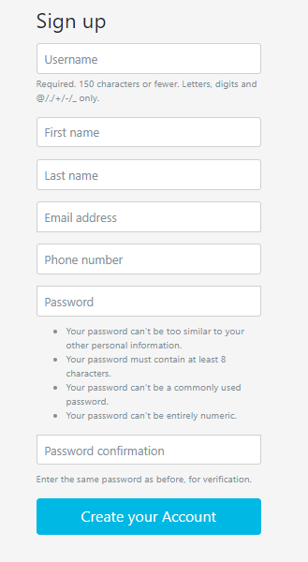

Update User Profile
- Login to your My Personal Commerce Account Banking application by typing https://commerce.umkc.scottah.com/ into your web browser. The Sign In screen will be brought up. Enter your Username and Password. Click the Sign In button. This will redirect you to your Dashboard.
- Click the User Profile icon from the menu on the left.
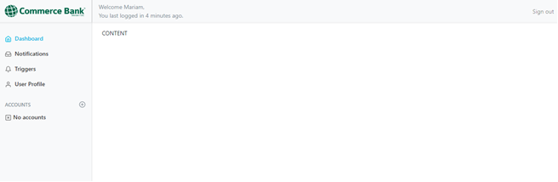

- Enter your desired changes and click the Update Profile button. To change your password, click Change Password. This will redirect you to the Change your password page.
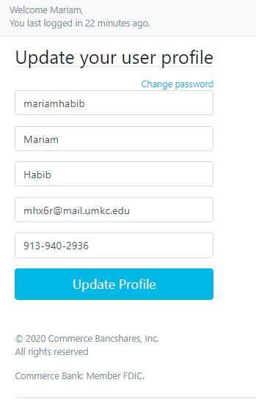

- Enter your old password, new password, and confirm your new password by typing it again in the password confirmation slot. Click the Change Password button.
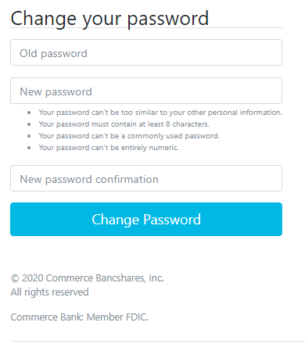

Set Triggers for Notification Rules
  - Login to your My Personal Commerce Account Banking application by typing https://commerce.umkc.scottah.com/ into your web browser. The Sign In screen will be brought up. Enter your Username and Password. Click the Sign In button. This will redirect you to your Dashboard.
  - Click the Triggers icon from the menu on the left.
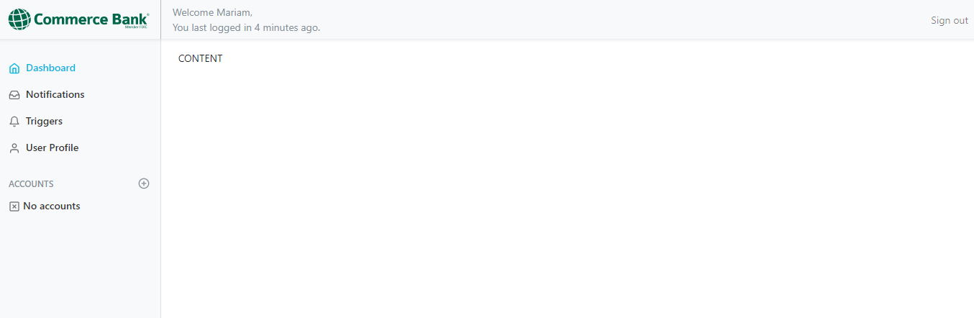
- To be notified when a user logs in or changes the profile information, click the Enabled button next to User Trigger. To determine how to be notified, click the Edit button to choose whether to be notified by Sms or Email. Choose which changes you would like to be notified about by choosing On login or On change. Click the Save button.
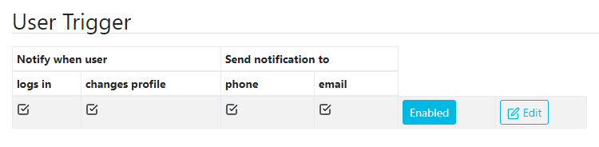
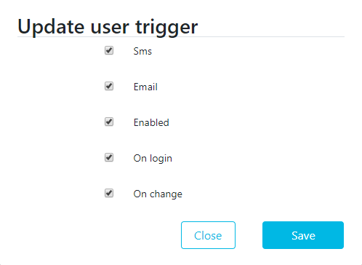

- To be notified when your account balance is greater than, less than, or equal to a certain amount, click the Add button next to Account Triggers. Select how you would like to be notified by either choosing Sms or Email. Select which Account you would like to receive notifications for. Choose the amount for Balance gte (Balance greater than) and/or Balance lte (Balance less than). Click the Save button.
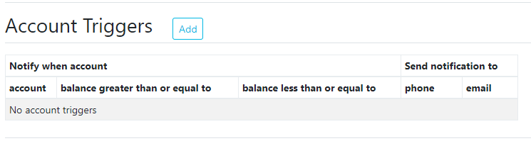
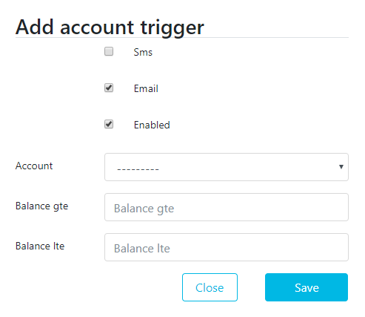

- To be notified when a transaction amount is greater than, less than, or equal to a certain amount, click the Add button next to Transaction Triggers. Select how you would like to be notified by either choosing Sms or Email. Select which Account you would like to receive transaction notifications for. Select credit or debit. Choose the Start and End date. Choose the amount for Amount gte (Amount greater than) and/or Amount lte (Amount less than). Type a Description value. Click the Save button.
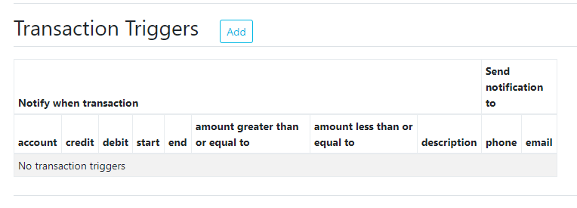
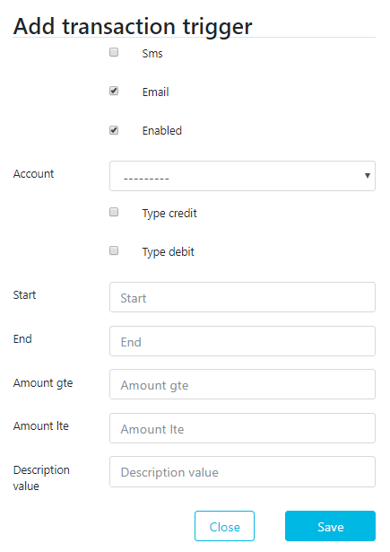

Add an Account
  - Login to your My Personal Commerce Account Banking application by typing https://commerce.umkc.scottah.com/ into your web browser. The Sign In screen will be brought up. Enter your Username and Password. Click the Sign In button. This will redirect you to your Dashboard.
  - Click the plus sign (+) next to the Account icon from the menu on the left. This will redirect you to the Add an Account page.
  - Enter your Account number and select if you would like your account to be a Checking or Savings account. Click the Add Account button.
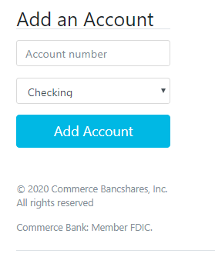

Add a Transaction
    - Login to your My Personal Commerce Account Banking application by typing https://commerce.umkc.scottah.com/ into your web browser. The Sign In screen will be brought up. Enter your Username and Password. Click the Sign In button. This will redirect you to your Dashboard.
    - Click on one of your accounts from the menu on the left. This will redirect you to the Transactions page.
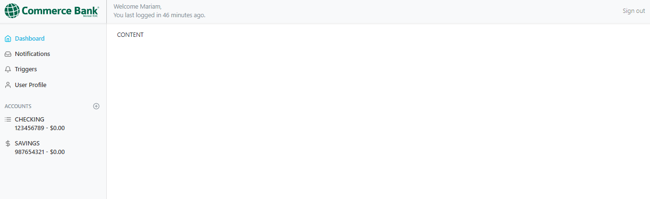
3. Click the Add button next to Transactions.
4. Enter the Amount and Description of the transaction. Click the Add Transaction button.
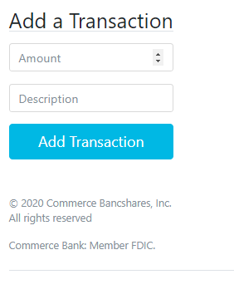

Troubleshooting

Forgot Password
      - Type https://commerce.umkc.scottah.com/ into your web browser. The Sign In screen will be brought up. Click Forgot your password? This will redirect you to the Reset Password page.
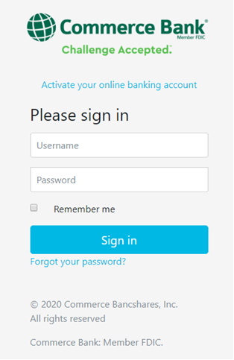

2. Type in your Email Address that is associated with your Commerce Bank account. Click the Send Email button. This will redirect you to a page that will tell you that the link to reset your password is sent to the email provided.
